FORECASTING ADOPTION OF TELEPRESENCE ROBOT TECHNOLOGY

*Supervisor: Zhangchen Hu*

*Department: ISDS*

*By:*

*Evan Duran*

*Jeevan Gowda*

*Hemanth Kumar*

*Adrian Vasquez*

*Nanditha Kolakaluru*

*Thanvitha Kolluri*

*Vamsi*

**INTRODUCTION**

MRTT, which combines telepresence and teleoperation, allows semi-autonomous robots to be operated remotely. The local environment is where the robot is located, and those who are in its presence are referred to as local users. The robot is controlled by a remote user, and through telepresence, they can virtually attend distant events, such as meetings, without being there physically. A remote telepresence robot (RTU) either has a screen built in or can be connected to separate screen devices (like a tablet or phone), depending on the manufacturer and product version. Apart from being able to walk, the device also has a wireless transmitter, video camera, and microphone for online communication.

The use of robotic telepresence in the workplace has the potential to reduce travel, provide instant access to others, save money on business expenses, and perhaps most importantly recent research indicates that it fosters collaboration that is comparable to in-person interaction, something that is not possible with a smartphone or tablet by itself.

The RTU market was estimated to be worth $825 million in 2015. According to one forecast, that value will rise to $7 billion by 20229, with a compound annual growth rate of 53.62% through 202010. One reason for the increase in RTU shipments worldwide is the number of companies launching new products.

*Figure 1: RTU Product Models*

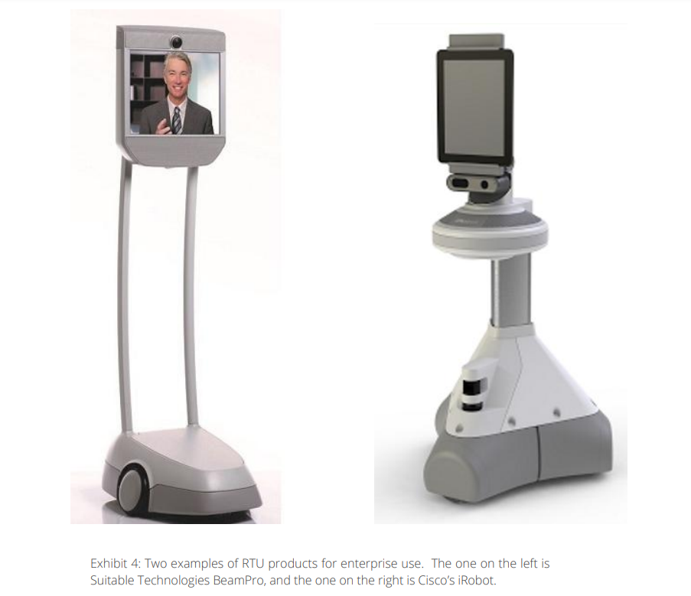

Five distinct RTUs that are currently in production are listed in the following exhibit. Notably, the "bring-your-own-device" business model is used by Double 2, Beam+, and PadBot in order to sell their products at lower price points. The gadget (such as an Apple iPad) is provided by the end user. Other RTUs that are offered at higher price points and marketed as "all-in-one" products include VGo, Ava 500, and BeamPro. These products have more extensive autonomous capabilities, which accounts for their higher prices. Specifically, iRobot's Ava 500 provides features like automated office mapping, which reduces end-user involvement and facilitates seamless enterprise integration.

*Figure 2: Overview of different RTUs*

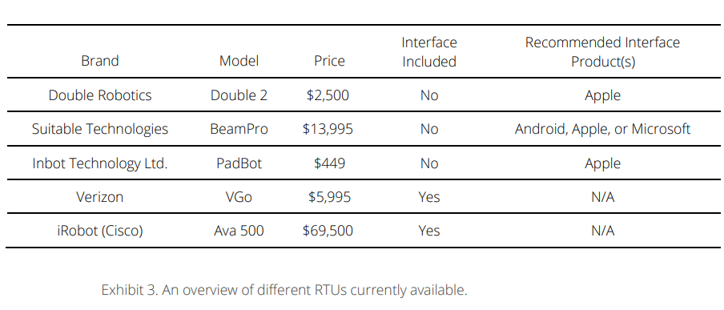

**BACKGROUND**

After Steve Ballmer resigned as CEO of Microsoft in 2014, Satya Nadella acquired the position. Microsoft has made an effort to break away from the previous CEO's "family of devices" tagline under its new CEO. Nadella released the following goal statement for Microsoft going forward in place of the device-centered strategy: "To enable every individual and every organization on the globe to attain greater success."To achieve this goal, Nadella promotes a mobile-first, cloud-first approach, where mobile-first refers to the mobility of experiences as well as devices. In order to strengthen this new emphasis, Microsoft made its largest acquisition to date in 2016 when it paid $26.2 billion to acquire LinkedIn.

Microsoft's planning and corporate strategy division is currently determining ways to increase the company's focus on mobile experiences in the business sector. There is a very even split between Microsoft and Cisco according to consumer preference surveys for enterprise UC. Some Microsoft executives were wondering what advantages robotic telepresence technology would offer businesses and what applications would be most applicable within businesses after seeing Cisco's collaboration with iRobot, the company that makes the robotic telepresence unit (RTU), iRobot Ava 500.

Within the company, there was a group that promoted a "watch and wait" strategy, which involved learning from the experiences of other companies like Cisco and being ready to jump in quickly if the technology took off. Others, however, favored a "lead the world" strategy, which called for the business to actively participate in the advancement and marketing of telepresence robot technology, closely collaborating with lead users to pinpoint lucrative applications.

In order to reconcile these two opposing strategies, the business made the decision to forecast mobile robotic telepresence technology (MRTT). To further its corporate mission, the company hoped that this kind of analysis would offer guidance when determining whether to make significant investments and/or acquisitions related to this technology.

**DATA DESCRIPTION**

The future success of telepresence robot technology hinges on its ability to provide tangible benefits in specific and well-defined applications. Early adopters have explored diverse applications across various industries, including enterprise management, healthcare, education, home care, military and defense, exploration, disaster recovery, and events. The potential areas for Remote Telepresence Unit (RTU) applications are broad and varied. Remote Telepresence Units (RTUs) offer global organizations and businesses the capability to streamline meetings, collaboration, sales, and marketing activities, while also facilitating efficient auditing, inspection, and maintenance tasks from a remote location.

In hospital and medical centers, Remote Telepresence Units play a crucial role by providing a communication interface for doctors and specialists to remotely interact with patients and enabling tele-operation for medical procedures.

It was anticipated that 2012 would mark a turning point in the use of RTU technology. 2012 saw a rise in sales, but it was far from a historic year due in part to the dependability of WiFi and the Internet (for instance, in medical applications). The high overall cost of purchasing and utilizing the technology was another contributing factor.

Even though these obstacles should become less in the future, how easily they are overcome will depend on a number of variables, including the location of the users and RTUs, the availability of resources, and most importantly the enterprise culture.

According to a company that tracks this sector, 6,500 RTU units were shipped globally in 2016 and 32,000 units are expected to be shipped in 2020.

*Figure 3: Telepresence robot units shipments forecast*

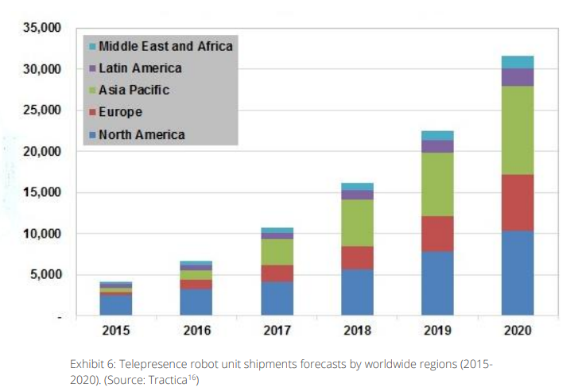

The adoption patterns for different enterprise technologies from 2006 to 2016 are summarized in the following chart, which is based on adoptions across companies globally in a variety of industries. For instance, 70% of these businesses have embraced social networks and blogs.

*Figure 4: Adoption Pattern*

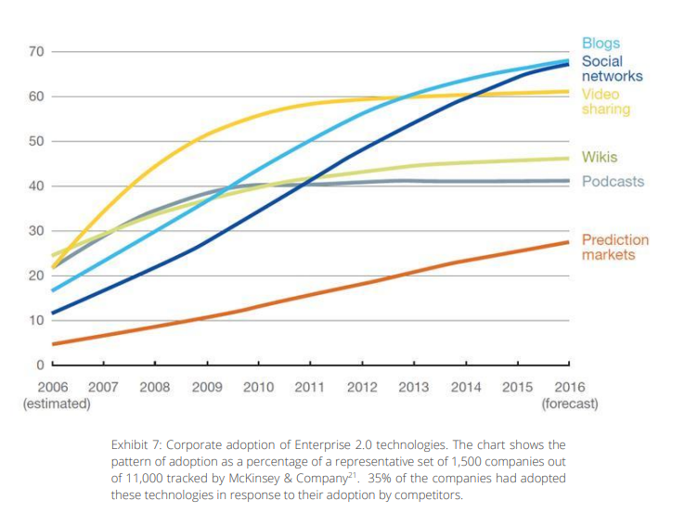

**ANALYSES**

|  |
| --- |
| **Question 1: Summarize and justify alternative scenarios (i.e., compelling stories about the future) ranging from pessimistic to optimistic regarding the market performance of remote telepresence robots (RTU).** |

Potential market outcomes for remote telepresence robots (RTUs) can be influenced by a range of issues, including political, environmental, commercial, and financial aspects. Here are a few scenarios that consider these factors, ranging from pessimistic to optimistic:

**Pessimistic Scenario:**

1. Political factors: Stricter laws and export restrictions on modern technology may make it more difficult for RTUs to be distributed internationally.
2. Environmental Factors: Environmental issues raise questions about how much energy and materials are utilized in the production of RTUs, which results in additional expenses and restrictions.
3. Market Factors: A saturated market with limited innovation and differentiation could lead to stagnation, as businesses are slow to adopt RTUs due to perceived risks.
4. Economic Factors: Businesses' willingness to invest in RTUs may be affected by financial challenges and downturns. This, combined with budget cuts, results in reduced acceptance rates.

Innovation and imitation coefficients are crucial in the Bass diffusion model. In the pessimistic scenario, the values for the innovation coefficient (p) and imitation coefficient (q) should indeed be low.

* Innovation Coefficient (p): The innovation coefficient is set at a low value of p=0.005 in this pessimistic scenario. This decision is supported by the expectation that political and economic limitations will result in slow innovation. These limitations might result in less money being spent on research and development, which would slow down the rate at which technology is developing.
* Imitation Coefficient (q): The imitation coefficient is set at a low value of q = 0.25 in this pessimistic scenario. This choice is in line with the theory that companies would be reluctant to imitate because of perceived risks and uncertainties. Under such circumstances, businesses are unwilling to embrace new technology because they are skeptical of allocating resources to unknown solutions.

**Moderate Scenario:**

1. Political factors: The RTU industry grows as a result of trade barriers being lowered and innovation being encouraged by supportive government policies and international cooperation.
2. Environmental Factors: In line with consumer and business environmental goals, the RTU industry embraces sustainability and produces highly efficient, environmentally friendly products.
3. Market Factors: A robust market with diverse RTU offerings tailored to different industries fuels moderate to rapid adoption, especially among medium to large enterprises.
4. Economic factors: As businesses recognize the benefits of lower travel costs and greater productivity in a globalized economy, stable economic conditions encourage the adoption of RTUs.
5. External factor: There are few external factor influencing an increase in the RTU adoption.

In the moderate scenario, the values for the innovation coefficient (p) and imitation coefficient (q) should be moderate, a bit higher than those in the pessimistic scenario.

* Innovation Coefficient (p): p = 0.0005 is the innovation coefficient in this moderate scenario. This selection denotes a moderate degree of innovation. Despite potential political and economic obstacles, some innovation is still expected in order to stay competitive and meet shifting consumer demands. Technological advancements are likely to occur gradually as a result of businesses and industries making modest investments in R&D.
* Imitation Coefficient (q): In this moderate scenario, the imitation coefficient is set at ￰q = 0.018. This exhibits an informative perspective on imitation. Businesses understand how important it is to adjust to shifting market dynamics, even though they may still be a little cautious. The imitation coefficient indicates that businesses are open to adopting new practices and are prepared to learn from early adopters.

**Optimistic Scenario:**

1. Political factors: Strong global investments and cooperation result in standardized rules and support for RTUs, allowing for quick global expansion.
2. Environmental Factors: A focus on green manufacturing and a small ecological footprint make the RTU sector a leader in environmental responsibility.
3. Market Factors: RTUs are being incorporated into a wide range of industries, including manufacturing, entertainment, and healthcare. Their adoption is huge.
4. Economic Factors: An incredibly dynamic and thriving RTU market is the outcome of a thriving global economy and businesses realizing the transformative power of RTUs for cost savings and productivity.
5. External influences: are high, and social media influencers and organizations start to use and promote the RTU, which increases their imation value.

In the optimistic scenario, the values for the innovation coefficient (p) and imitation coefficient (q) are set higher.

* Innovation Coefficient (p): The innovation coefficient in this optimistic scenario is p = 0.001. This selection demonstrates a high degree of innovation. Political and economic factors are thought to foster innovation and speed up the pace of technological advancement. It is anticipated that companies and sectors will make large investments in R&D to maintain market leadership and obtain a competitive advantage.
* Imitation Coefficient (q): In this optimistic scenario, the imitation coefficient is set at ￰ q=0.60. This indicates that businesses are very open to adopting new technologies. Businesses understand how crucial it is to quickly adjust to shifting market conditions, and they are willing to take in suggestions from early adopters. The imitation coefficient indicates that businesses are quick to embrace new developments in the market and take a proactive approach to implementing new procedures and technologies.

|  |
| --- |
| **Question 2: Develop forecasts of robotic telepresence penetration in the U.S. market from 2017 to 2026 along with a justification and explanation for your forecasts based on one or more scenarios you developed. (In applying the Bass model, note that market penetration data for the three analog products mentioned in the case, namely, fax machines, LinkedIn, and 3D printers, were all reckoned in terms of the percentage of the target market that adopted the product. Thus, the maximum market potential can be set to 100 for developing the forecasts** |

*Figure 5: Bass Forecasts Pessimistic Scenario*

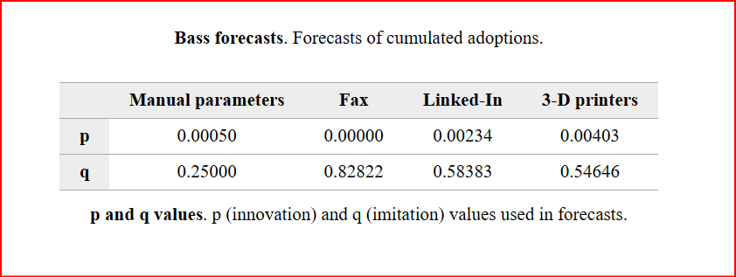

For this Pessimistic scenario the innovation factor is set to .0005 because RTU technology is not as new or novel compared to the 3d printer and fax machines which are respectively set .002-.004. In addition our forecast horizon is set to 40 periods which is 4 periods * 10 years. While the RTU has the ability to disrupt certain industries such as medical, and security it would need to see widespread adoption to become successful. However, it has yet to do this. With current technology such as Cell phones and tablets able to accomplish the same functions as RTUs there is much uncertainty as to what added value the mobility feature of the RTU offers to prospective customers.

*Figure 6: Related forecasts Pessimistic Scenario*

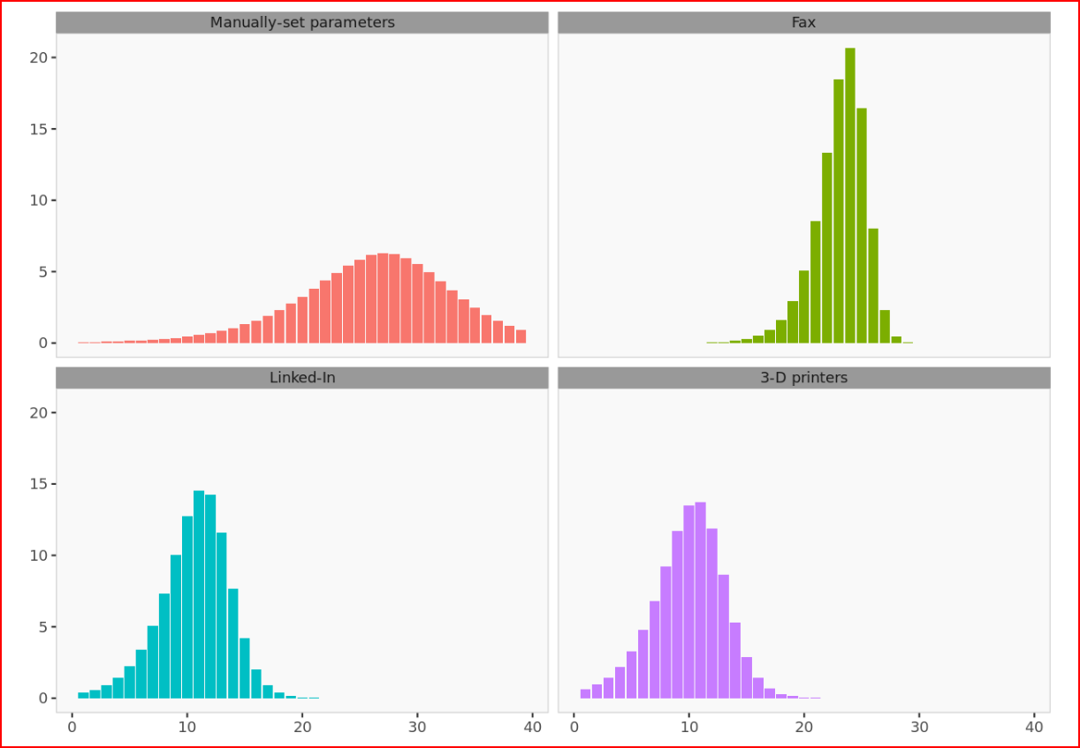

As for the imation value we choose to set it to .25 due to the external factors mentioned above. Since both the imitation and innovation values are significantly lower than other similar technology our forecast is significantly lower. With these pessimistic parameters our forecast volume and growth slower and lower. The forecast is spread out over a longer period, and the peak forecast takes around 28 periods which is 7 years . The max number of adopters in one period is a 7% market adoption, while other other technologies peak adoption is much higher at ranges from 15-20. Also linkedin and 3d printers peak at period 10 which is 2.5 year and our pessimistic forecast peaks at 7 years. However, the fax machine took awhile to catch on but once it did it had fast adoption, and growth was much faster.

*Figure 7: Bass forecasts Optimistic scenario*

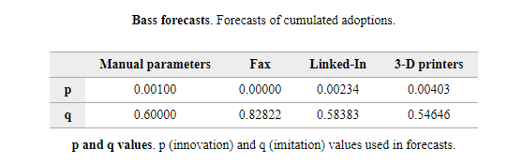

*Figure 8: Related forecasts Optimistic scenario*

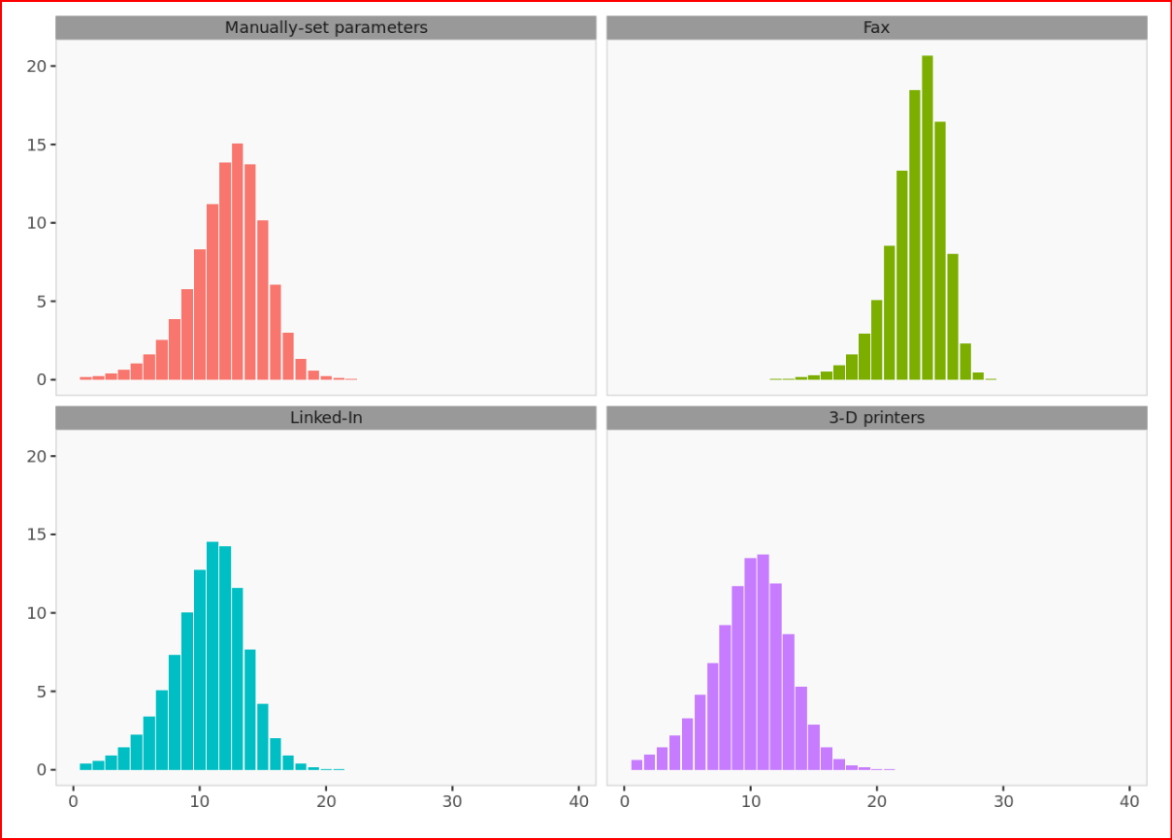

In our optimistic scenario we opted to increase both the innovation and imitation values of our bass model to p = 0.001 and to q = 0.60. Doubling the Imitation value had a drastic impact on our models predicted adoption of RTU technology. The optimistic scenario adoption per period graph for RTUs shown in figure 8, tops out at 15 while the average of the other products is 16%. When compared to the other test products, RTU’s were able to reach maturity within the market quicker with the average time it takes for similar products to mature or peak being 15 periods while the telepresence takes 12 periods. The optimistic scenario for this product bodes similarities to the actual scenario for linkedIn and 3D printing which can be seenb by the similarity in their product adoption graphs. In this scenario the RTUs market adoption appears to be similar to other products despite having a relatively low innovation value.We figure that many organizations, and institutions could adopt this technology triggering further imation which will improve the speed and volume of sales.

|  |
| --- |
| **Question 3: Recommend short-term and long-term strategies that Microsoft should pursue based on the forecasts that you develop.** |

**Short term Strategies:**

In the short term Microsoft should focus on finding novel ways to include RTUs into common practice in order to build customer familiarity with the product. With RTUs being a fairly new and unique piece of technology, it lends itself to customer confusion and lack of understanding. We can see in our pessimistic scenario that failing to gain customer adoption in the early periods greatly caps the RTUs market share in the long run. Additionally, Microsoft should try and show how the mobility aspect of the technology sets it apart from other comparable products like zoom, and other conference services.

**Long term Strategies:**

In the long term Microsoft needs to focus on building a stable user base which can give the product the possibility for long term growth. Microsoft should create useful features and capabilities of their RTUs which make their adoption hurdles like complexity, and unfamiliarity worth the cost. Further development should consider ways in which multiple RTUs could function synergistically so that organizational adoption through places like hospitals and large businesses can be encouraged. We can see from the adoption of the fax machine that steady adoption can lead to a strong user base which can create network effects growing overall market share.

**CONCLUSION AND MANAGERIAL INSIGHTS**

Here are a few of the MRTT-related issues. At the time, there were only clumsy web-based buttons for controlling the robot, but these days it would probably use a VR rig and a game controller, or at least an app for a mobile device.Presenting the remote user in a relatable manner was never given priority by designers. In the rare cases when a screen was present, it was always small, and users interacted with a goofy toy. There wasn't much fast internet available, so the lag was awful. It differed from using Zoom.

Particularly since the pandemic, Zoom, Microsoft teams, Google meets etc., have grown rapidly. In a sense, "telepresence" is a big deal, but nobody has a robot for telepresence, and everyone has a laptop, and the interfaces are too similar for anyone to really care. These days, telepresence is essentially a zoom call that you make with a steerable robot albeit one that is less dependable and more difficult to use than a stationary laptop.

It would become popular in certain applications, such as factory tours or inspections (drone inspection of high-risk, remote, or isolated areas is already common), if they had improved interfaces and increased reliability to the point where it "just worked" for the majority of users and the cost was identical (i.e., amortized, shared units).